**System Requirements Specifications for Roadie**

Sponsor

**Electrical, Computer, Software & Systems Engineering at Embry-Riddle Aeronautical University**

Released 12 September 2014

**Are We There Yet?**

Table of Contents

**Revision History** 4

**1.** **Introduction** 5

**1.1** **Purpose** 5

**1.2** **Problem Statement** 5

**1.3** **Scope** 5

**1.4** **Team Information** 5

**1.5** **Overview** 5

**2.** **Overall Description** 7

**2.1** **Stakeholders** 7

**2.2** **Product Perspective** 7

**2.3** **Product Functions** 7

**2.4** **Use Cases** 7

**2.4.1** **Use Case 1: Full Completion of the Course** 8

**2.4.2** **Use Case 2: Simon Challenge** 10

**2.4.3** **Use Case 3: Etch-A-Sketch Challenge** 12

**2.4.4** **Use Case 4: Rubik’s Cube Challenge** 13

**2.4.5** **Use Case 5: Card Challenge** 14

**2.5** **Sequence Diagrams** 15

**2.5.1** **Use Case 1** 15

**2.5.2** **Use Case 2** 16

**2.5.3** **Use Case 3** 17

**2.5.4** **Use Case 4** 18

**2.5.5** **Use Case 5** 19

**3.** **Functional Requirements** 20

**3.1** **Movement** 20

**3.2** **Navigation** 20

**3.3** **Challenge Completion** 20

**4.** **Non-Functional Requirements** 20

**4.1** **System Size** 20

**4.2** **Power Management** 20

**4.3** **Start Method/Operation** 20

**5.** **Glossary** 22

**6.** **Acronyms and Abbreviations** 23

**7.** **Appendix A** 24

**8.** **References** 25

Table of Figures

**Fig. 1** Use Case: Full completion of the course sequence diagram 15

**Fig. 2** Use case: Simon challenge sequence diagram 16

**Fig. 3** Use case: Etch-A-Sketch challenge sequence diagram. 17

**Fig. 4** Use case: Rubik’s cube challenge sequence diagram 18

**Fig. 5** Use case: Card challenge sequence diagram. 19

**Fig. 6** Competition course for SoutheastCon[1]. 24

Figure 7 25

Figure 8: The exact Rubik's cube to be used during competition. 26

Figure 9 27

# **Revision History**

|  |  |  |
| --- | --- | --- |
| Date | Reason for Change | Version |
| 15 Sep 2014 | Jorge Peer Review | 0.6.0 |
| 12 Sep. 2014 | Style Formatting | 0.5.0 |
| 12 Sep 2014 | Added Use Cases and Sequence Diagrams | 0.4.0 |
| 10 Sep 2014 | Added Overall Description | 0.3.0 |
| 9 Sep 2014 | In-class revision | 0.2.0 |
| 7 Sep 2014 | Initial Draft | 0.1.0 |

# **Introduction**

## **Purpose**

The purpose of this document is to define the system requirements of Roadie, the robot put forth by team Are We There Yet (AWTY) to compete in the 2015 Institute of Electrical and Electronics Engineers (IEEE) SoutheastCon student hardware competition. These requirements include both functional requirements and non-functional requirements. This document is intended for the customer of AWTY, the requirements engineering team for AWTY, the design, testing and quality assurance teams, as well as all other teams involved in the development and construction.

## **Problem Statement**

To create an autonomous robot to compete in the 2015 IEEE SoutheastCon student hardware competition.

## **Scope**

Roadie is intended to compete in the 2015 IEEE Southeast Con student hardware competition. The system is envisioned to complete four unique challenges:

* Correctly play Simon for 15 seconds
* Draw “IEEE” on an Etch-A-Sketch
* Twist one row of a Rubik’s cube 180 degrees
* Pick up and carry one playing card across the finish line

Roadie system is intended to successfully complete the challenges outlined above within a time limit of five minutes.

Roadie is not intended to serve any other functions or fulfill any other purposes other than competing in the 2015 IEEE SoutheastCon competition.

## **Team Information**

|  |  |
| --- | --- |
| Name | Role |
| Brian Powell | Team Leader |
| Michael Philotoff | Software Configuration Manager |
| Alex Senopoulos | Testing Leader |
| Brian Sterling | Development Leader |

## **Overview**

Section 1 of this document serves as introduction to the system designed by AWTY. Section 2 provides an overall description of the system, including stakeholders involved in the project, the functions of the system and proposed use cases for the system. Section 3 describes the functional and Section 4 describes the non-functional requirements of the system.

The glossary contains definitions of all industry and standard terms as well as ambiguous terms, used throughout this document. Additionally, a list of acronyms and abbreviations can be found following the glossary. A picture of the course is included in Appendix A.

# **Overall Description**

## **Stakeholders**

The following list describes the individuals and parties involved in, or that have a stake in, the development, productions and operation of Roadie.

* + 1. **Team AWTY**

As the development team, there is a vested interest in terms of grades. The grades will be based upon the completion of the system, as well as meeting customer demands. Additionally, efforts should be made to apply principles and concepts learned while at Embry-Riddle Aeronautical University (ERAU).

* + 1. **Dr. Barott, Dr. Seker and Jorge Torres**

As customers of team AWTY, Dr. Barott, Dr. Seker and Jorge Torres are interested in the completion of the product as outlined in this document. Furthermore, Dr. Barott and Dr. Seker are interested in ensuring that the project meets the standards set forth by Department of Electrical, Computer, Software & Systems Engineering (ECSSE) at ERAU.

* + 1. **ERAU**

Since the University is an indirect sponsor of the project, any actions taken by the development team reflect directly back upon the University.

* + 1. **ECSSE Department**

As the direct sponsor of the project, the department is interested in making sure the project is delivered both on time and on budget.

* + 1. **IEEE**

As the sponsor of the competition for which the final system will compete in, the IEEE is interested in making sure that the final system complies with all competition rules and that the development team has conducted themselves in a manner befitting of a professional organization.

## **Product Perspective**

Roadie system is intended to be an autonomous robot whose sole purpose is to compete in the IEEE 2015 SoutheastCon student hardware competition.

## **Product Functions**

Roadie is broken down into five major subsystems: (1) the line following subsystem, (2) the Simon subsystem, (3) the Etch-a-Sketch subsystem, (4) the Rubik’s cube subsystem and (5) the playing card subsystem. The purpose of these subsystems is to facilitate the requirements engineering process.

## **Use Cases**

The following use cases demonstrate the intended operations of Roadie. The use cases outline the intended sequence of events as well as the procedures that will be followed in the event of a system failure.

Note: “*” indicates at any given time, during the use case.

## **Use Case 1: Full Completion of the Course**

Scope: Roadie

Level: User goal

Primary Actors: Roadie

**Stakeholders & Interests**

* **Team AWTY** - As the development team, there is a vested interest in terms of grades. The grades will be based upon the completion of the system, as well as meeting customer demands. Additionally, efforts should be made to apply principles and concepts learned while at ERAU.
* **Dr. Barott, Dr. Seker and Jorge Torres -** As customers of team AWTY, Dr. Barott, Dr. Seker and Jorge Torres are interested in the completion of the product as outlined in this document. Furthermore, Dr. Barott and Dr. Seker are interested in ensuring that the project meets the standards set forth by ECSSE at ERAU.
* **ERAU -** Since the University is an indirect sponsor of the project, any actions taken by the development team reflect directly back upon the University.

**Preconditions**

* Roadie has been place in the 1 ft. x 1 ft. starting square on the Two-dimensional playing field.
* Roadie has been turned to the on position.

**Postconditions**

* Roadie crosses the finish line holding a single playing card.

**Main Success Scenario**

* Roadie waits for the red LED to turn off.
* Roadie starts line following and makes turns based on which way the line is turning until the first challenge zone.
* Roadie completes the first challenge as described in Use Case: Simon Challenge.
* Roadie turns around and begins to line follow until the second challenge zone.
* Roadie completes the second challenge as described in Use Case: Etch-A-Sketch Challenge.
* Roadie turns around and beings to line follow until the third challenge zone.
* Roadie completes the third challenge as described in Use Case: Rubik Cube Challenge.
* Roadie turns around and beings to line follow until the fourth challenge zone.
* Roadie completes the fourth challenge as described in Use Case: Card Challenge.
* Roadie turns around and beings to line follow until crossing the finish line while holding onto a card.

**Extensions (Alternate Flows)**

*a. Roadie is in a bad state.

1. Roadie will backtrack last known good state.

2. Roadie shall proceed with the next steps to take.

**Frequency of Occurrence**

This use case will occur each time the system is placed within the 1 ft. x 1 ft. white square. During the competition this shall occur three times due to there being three rounds for each robot that is entered.

## **Use Case 2: Simon Challenge**

Scope: Roadie

Level: User goal

Primary Actors: Roadie

**Stakeholders & Interests**

* **Team AWTY** - As the development team, there is a vested interest in terms of grades. The grades will be based upon the completion of the system, as well as meeting customer demands. Additionally, efforts should be made to apply principles and concepts learned while at ERAU.
* **Dr. Barott, Dr. Seker and Jorge Torres -** As customers of team AWTY, Dr. Barott, Dr. Seker and Jorge Torres are interested in the completion of the product as outlined in this document. Furthermore, Dr. Barott and Dr. Seker are interested in ensuring that the project meets the standards set forth by ECSSE at ERAU.
* **ERAU -** Since the University is an indirect sponsor of the project, any actions taken by the development team reflect directly back upon the University.

**Preconditions**

* Roadie has reached the Simon challenge zone.

**Postconditions**

* Roadie completes playing Simon for 15 seconds.

**Main Success Scenario**

* Roadie correctly identifies the challenge to be the Simon challenge zone.
* Roadie lines itself up at the Simon playing piece.
* Roadie pushing the start button located on the Simon.
* Roadie correctly identifies which colors and order the Simon has lit up.
* Roadie pushes each button in the order at which the Simon has lit up.
* Roadie repeats steps 4 and 5 until 15 seconds has passed.

**Extensions (Alternate Flows)**

*a. Roadie fails to respond or correctly push buttons in order to where Simon signals the failure sound.

1. Roadie shall restart at step 3 again and continue on with steps 4 and 5 (this process does not reset the 15 second timer).

**Frequency of Occurrence**

This use case will occur every time Roadie reaches and identifies the challenge to be the Simon challenge. During the competition this shall occur three times due to there being three rounds for each robot that is entered and this challenge shall occur once per round.

## **Use Case 3: Etch-A-Sketch Challenge**

Scope: Roadie

Level: User goal

Primary Actors: Roadie

**Stakeholders & Interests**

* **Team AWTY** - As the development team, there is a vested interest in terms of grades. The grades will be based upon the completion of the system, as well as meeting customer demands. Additionally, efforts should be made to apply principles and concepts learned while at ERAU.
* **Dr. Barott, Dr. Seker and Jorge Torres -** As customers of team AWTY, Dr. Barott, Dr. Seker and Jorge Torres are interested in the completion of the product as outlined in this document. Furthermore, Dr. Barott and Dr. Seker are interested in ensuring that the project meets the standards set forth by ECSSE at ERAU.
* **ERAU -** Since the University is an indirect sponsor of the project, any actions taken by the development team reflect directly back upon the University.

**Preconditions**

* Roadie has arrived at the Etch-A-Sketch challenge zone.

**Postconditions**

* Roadie completes drawing “IEEE” using the Etch-A-Sketch.

**Main Success Scenario**

* Roadie correctly identifies the challenge to be the Etch-A-Sketch challenge.
* Roadie lines itself up with the Etch-A-Sketch.
* Roadie twist the two knobs to draw “IEEE” on the Etch-A-Sketch (Font and Size [TBD]).

**Extensions (Alternate Flows)**

*a. Roadie is in a bad state.

1. Roadie will backtrack last known good state.

2. Roadie shall proceed with the next steps to take.

**Frequency of Occurrence**

This use case will occur every time Roadie reaches and identifies the challenge to be the Simon challenge. During the competition this shall occur three times due to there being three rounds for each robot that is entered and this challenge shall occur once per round.

## **Use Case 4: Rubik’s Cube Challenge**

Scope: Roadie

Level: User goal

Primary Actors: Roadie

**Stakeholders & Interests**

* **Team AWTY** - As the development team, there is a vested interest in terms of grades. The grades will be based upon the completion of the system, as well as meeting customer demands. Additionally, efforts should be made to apply principles and concepts learned while at ERAU.
* **Dr. Barott, Dr. Seker and Jorge Torres -** As customers of team AWTY, Dr. Barott, Dr. Seker and Jorge Torres are interested in the completion of the product as outlined in this document. Furthermore, Dr. Barott and Dr. Seker are interested in ensuring that the project meets the standards set forth by ECSSE at ERAU.
* **ERAU -** Since the University is an indirect sponsor of the project, any actions taken by the development team reflect directly back upon the University.

**Preconditions**

* Roadie has arrived at the Rubik’s Cube challenge zone.

**Postconditions**

* Roadie twisted a row of the Rubik’s Cube 180 degrees.

**Main Success Scenario**

* Roadie correctly identifies the challenge to be the Rubik’s Cube challenge zone.
* Roadie lines itself up with the Rubik’s Cube.
* Roadie twist one of the rows of Rubik’s Cube 180 degrees.

**Extensions (Alternate Flows)**

*a. Roadie is in a bad state.

1. Roadie will backtrack last known good state.

2. Roadie shall proceed with the next steps to take.

**Frequency of Occurrence**

This use case will occur every time Roadie reaches and identifies the challenge to be the Simon challenge. During the competition this shall occur three times due to there being three rounds for each robot that is entered and this challenge shall occur once per round.

## **Use Case 5: Card Challenge**

Scope: Roadie

Level: User goal

Primary Actors: Roadie

**Stakeholders & Interests**

* **Team AWTY** - As the development team, there is a vested interest in terms of grades. The grades will be based upon the completion of the system, as well as meeting customer demands. Additionally, efforts should be made to apply principles and concepts learned while at ERAU.
* **Dr. Barott, Dr. Seker and Jorge Torres -** As customers of team AWTY, Dr. Barott, Dr. Seker and Jorge Torres are interested in the completion of the product as outlined in this document. Furthermore, Dr. Barott and Dr. Seker are interested in ensuring that the project meets the standards set forth by ECSSE at ERAU.
* **ERAU -** Since the University is an indirect sponsor of the project, any actions taken by the development team reflect directly back upon the University.

**Preconditions**

* Roadie has arrived at the card challenge zone.

**Postconditions**

* Roadie has picked up a single playing card.

**Main Success Scenario**

* Roadie correctly identifies the challenge to be the card challenge zone.
* Roadie lines itself up with the deck of cards.
* Roadie picks up a single playing card.
* Roadie continues to carry the playing card that was picked up.

**Extensions (Alternate Flows)**

*a. Roadie is in a bad state.

1. Roadie will backtrack last known good state.

2. Roadie shall proceed with the next steps to take.

**Frequency of Occurrence**

This use case will occur every time Roadie reaches and identifies the challenge to be the Simon challenge. During the competition this shall occur three times due to there being three rounds for each robot that is entered and this challenge shall occur once per round.

## **Sequence Diagrams**

## **Use Case 1**

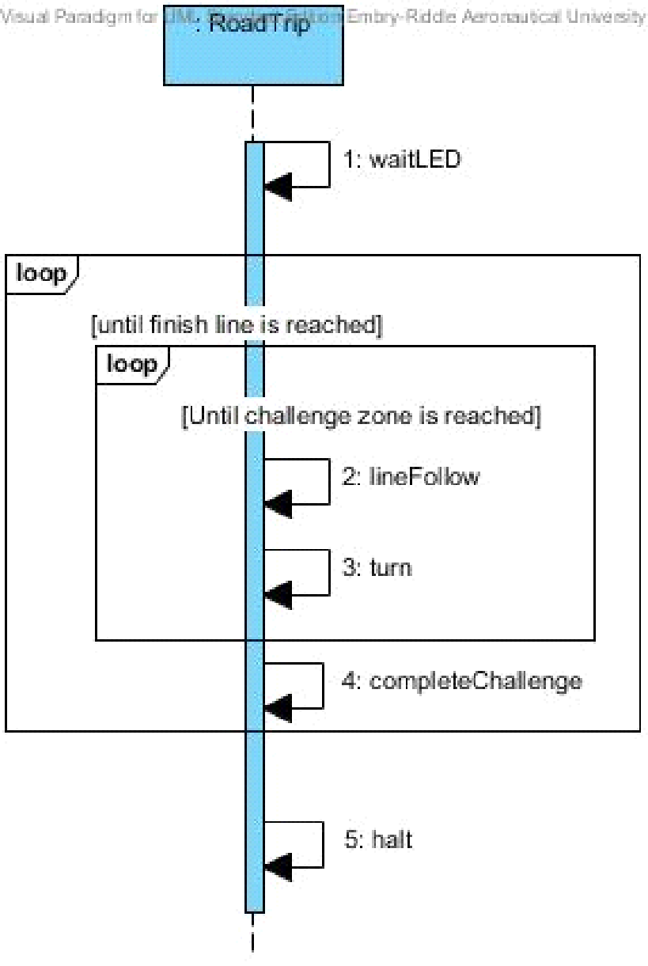**For the Use Case**: Full completion of the Course Sequence Diagram as shown in **Fig. 1** below shows how the system will communicate with its self to complete the course for the 2015 IEEE SoutheastCon competition.

**Fig. 1** Use Case: Full completion of the course sequence diagram

## **Use Case 2**

**For the Use Case:** Simon Challenge Sequence Diagram as shown in **Fig. 2** below shows the steps Roadie shall take in order to complete the Simon challenge.

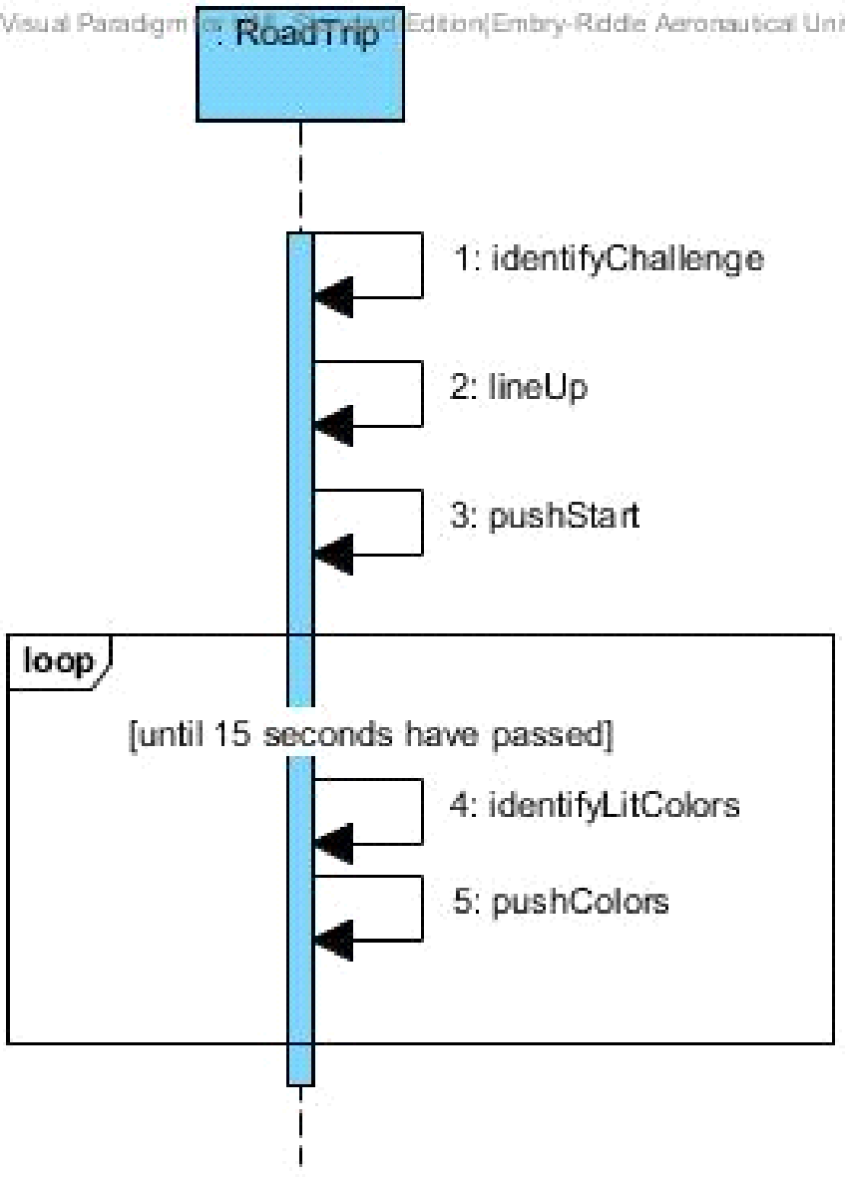

**Fig. 2** Use case: Simon challenge sequence diagram

## **Use Case 3**

**For the Use Case:** Etch-A-Sketch Challenge Sequence Diagram as shown in **Fig. 3** below shows the steps Roadie shall take in order to complete the Etch-A-Sketch challenge.

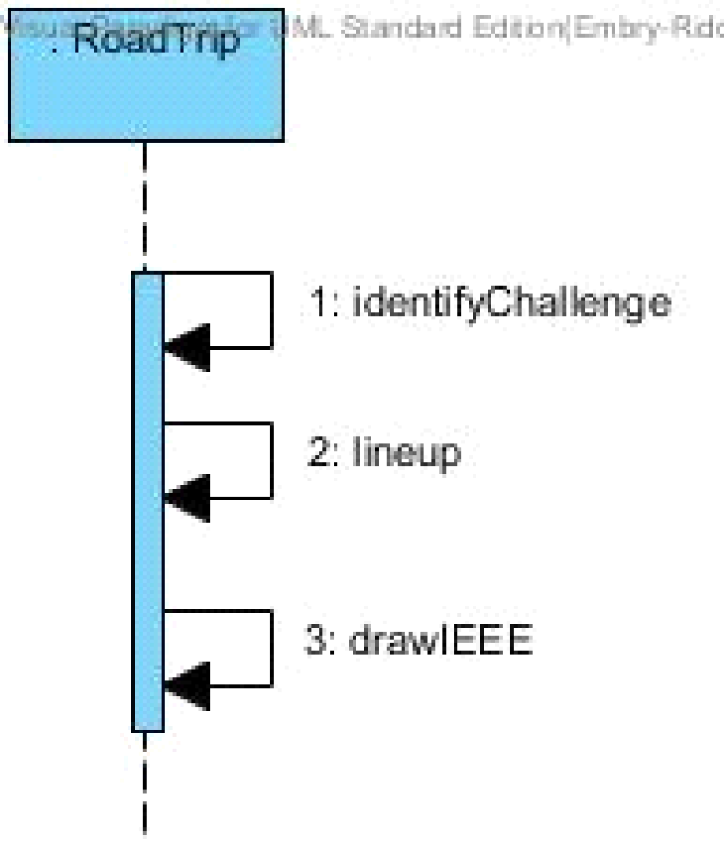

**Fig. 3** Use case: Etch-A-Sketch challenge sequence diagram.

## **Use Case 4**

**For the Use Case:** Rubik Challenge Sequence Diagram as shown in **Fig. 4** below shows the steps Roadie shall take in order to complete the Rubik’s cube challenge.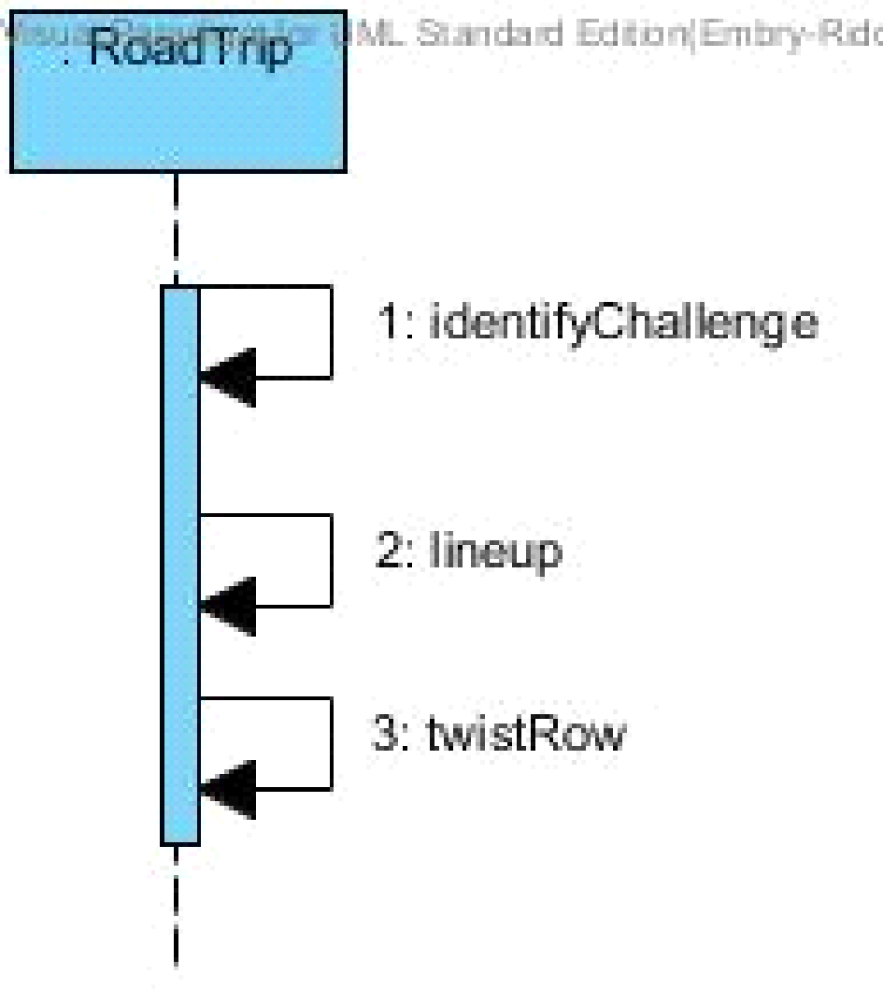

**Fig. 4** Use case: Rubik’s cube challenge sequence diagram

## **Use Case 5**

**For the Use Case:** Card Challenge Sequence Diagram as shown in Fig. 5 below shows the steps Roadie shall take in order to complete the card challenge.

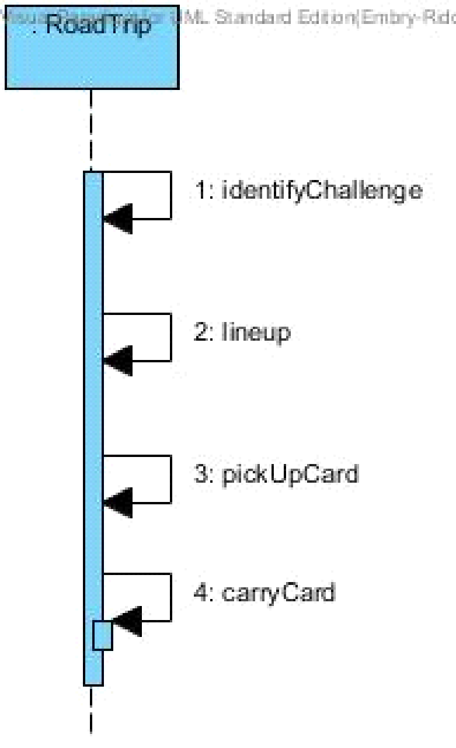

**Fig. 5** Use case: Card challenge sequence diagram.

# **Functional Requirements**

* 1. **Movement**
     1. The system shall move in the two-dimensional playing field shown in **Fig. 6**.
     2. The system shall move from the starting area to the Simon Carabineer along the Scotch Blue Painter’s tape.
     3. The system shall move from the Simon Carabineer to the Pocket Etch-a-Sketch along the Scotch Blue Painter’s tape.
     4. The system shall move from the Pocket Etch-a-Sketch to the Rubik’s Cube along the Scotch Blue Painter’s tape.
     5. The system shall move from the Rubik’s Cube to the deck of playing cards along the Scotch Blue Painter’s tape.
     6. The system shall move from the deck of playing cards to the finish line along the Scotch Blue Painter’s tape.
     7. The system shall identify the red [RGB value TBD] LED in the starting area.
     8. The system shall wait for red [RGB value TBD] LED to turn off before exiting starting area.
  2. **Navigation**
     1. The system shall track its movement along the white Scotch Blue Painter’s tape.
     2. The system shall identify the challenge zones and stop movement.
  3. **Challenge Completion**
     1. The system shall correctly identify the challenge zone upon arrival.
     2. The system shall align with the challenge before attempting to complete the challenge.
     3. The system shall play the Simon carabineer depicted in **Fig 7.**
        1. The system shall play Simon for 15 seconds.
        2. The system shall initiate Simon game by pressing the start button.
        3. The system shall correctly sense color blue [exact RGB values TBD] when illuminated on Simon board.
        4. The system shall correctly sense color red [exact RGB values TBD] when illuminated Simon board.
        5. The system shall correctly sense color yellow [exact RGB values TBD] when illuminated Simon board.
        6. The system shall correctly sense color green [exact RGB values TBD] when illuminated Simon board.
        7. The system shall not obstruct Simon carabineer during play.
        8. The system shall respond to Simon before its buzzer sounds.
     4. The system shall twist one row of a Rubik’s cube 180 degrees (SKU:DAD09D9E).
        1. The system shall not obstruct the Rubik’s cube during play.
     5. The system shall draw “IEEE” on a Pocket Etch-A-Sketch (SKU:FD79DD3F).
        1. The system shall use [Font and Size TBD] for drawing “IEEE”.
        2. The system shall not obstruct the Etch-A-Sketch during play.
     6. The system shall collect a single playing card [Exact deck TBD].
        1. The system shall carry playing card across finish line.
        2. The system shall keep the card in a usable condition.

# **Non-Functional Requirements**

* 1. **System Size**
     1. The system size shall be no greater than 1ft. x 1ft. x 1ft. within the starting area and the finishing area.
  2. **Power Management**
     1. The system shall operate for a minimum of three consecutive course rounds each having duration of five (5) minutes, on one battery life.
  3. **Start Method/Operation**
     1. The system shall have an easily accessible power switch.
     2. The system shall be completely autonomous after being powered on.
     3. The system shall maintain contact with the course surface at all times.

# **Glossary**

|  |  |  |
| --- | --- | --- |
| Entry | Definition | Aliases |
| SoutheastCon | SoutheastCon is the annual IEEE Region 3 Technical, Professional, and Student Conference. It brings together Computer Scientists, Electrical, and Computer Engineering professionals, faculty and students to share the latest information through technical sessions, tutorials, and exhibits. It is the most influential conference in Region 3 for promoting awareness of the technical contributions made by our profession to the advancement of engineering science and to the community. As usual, attendance and technical program participation from areas outside IEEE Region 3 are encouraged and welcomed. IEEE Region 3 encompasses the southeastern United States and includes the states of Alabama, Florida, Georgia, areas of Indiana, Kentucky, Mississippi, North Carolina, South Carolina, Tennessee, Virginia and the country of Jamaica [3]. |  |
| Institute of Electrical and Electronics Engineers | IEEE is the world's largest professional association dedicated to advancing technological innovation and excellence for the benefit of humanity. IEEE and its members inspire a global community through IEEE's highly cited publications, conferences, technology standards, and professional and educational activities [4]. | IEEE |
| Bad state | Any state that has not been programmed into the system. |  |
| Good state | Any state that the robot can recognize and attempt completion. |  |
| Obstruct | SoutheastCon rules state that the system cannot obstruct any obstacle [1]. |  |
| Autonomous | The robot is autonomous since it has to independently operate [2]. No human inputs will be given to it. |  |
| Two-dimensional playing field | The two-dimensional playing field is the plywood board where the competition is being held on. The system must maintain contact with the board at all times. |  |
| Usable Condition | SoutheastCon rules state that the playing card must be left in a usable condition [1]. |  |
| Starting Area | A one foot by one foot area on the two-dimensional playing field marked by Scotch Blue Painter’s tape [1]. |  |
| Course Round | A span of five minutes during which the system is expected to complete the 4 challenges [1]. |  |
| Challenge Zone | The 1ft. x 1ft. areas where each of the specific challenges will be placed along the course. |  |
| Align | The system will position itself so the appendages can properly reach the challenges. |  |
| Simon Carabineer | The Simon Carabineer has an SKU of 226CE810 [1]. It is a game in which buttons are pressed in order to respond to light and sound sequences. | Simon, Simon board |
| Rubik’s Cube | The Rubik’s Cube has an SKU of DAD09D9E [1]. |  |
| Pocket Etch-A-Sketch | The Pocket Etch-A-Sketch has an SKU of FD79DD3F [1]. | Etch-A-Sketch |
| Playing Card | The playing card is part of a deck of cards. The SKU of the card deck is TBD [1]. |  |
| Scotch Blue Painter’s Tape | The Scotch Blue Painter’s tape is identified by Home Depot’s, Model# 2090-1J Store SKU # 958999 [1]. It is the color white. |  |
| Finish Line | The finish line is the ending point of the competition. It is the point where the Scotch Blue Painter’s Tape comes to the final “T” shape on the course [1]. It is marked as FINISH in **Fig. 6**. |  |

# **Acronyms and Abbreviations**

|  |  |
| --- | --- |
| Acronym | Meaning |
| AWTY | Are We There Yet |
| IEEE | Institute of Electrical and Electronics Engineers |
| ECSSE | Electrical, Computer, Software & Systems Engineering |
| ERAU | Embry-Riddle Aeronautical University |

# **Appendix A**

This appendix includes a diagram of the competition course as well as pictures of the individual challenges the system must complete. Also included is a picture of the tape that will designate the line the system must follow.

## **Competition Course**

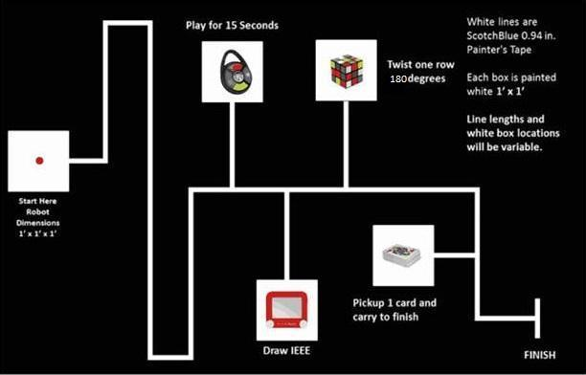The course, as shown in **Fig. 6** below, shows the rough outline of the track the system will follow, as well as what a challenge station would look like.

**Fig. 6** Competition course for SoutheastCon[1].

## **Simon carabineer**

The Simon carabineer, as seen in **Fig. 7** is the specific Simon game that the system will play.

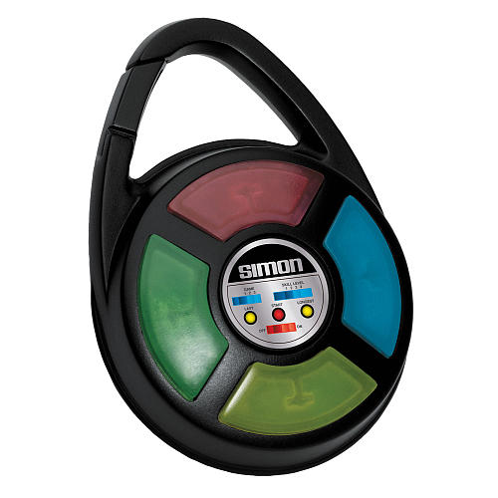

Figure : The exact Simon carabineer to be used during competition.

## **Rubik’s Cube**

The Rubik’s cube, as seen in **Fig 8** is the specific Rubik’s cube that the system will play.

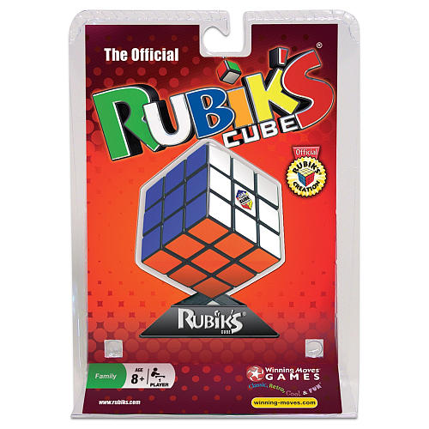

Figure : The exact Rubik's cube to be used during competition.

## **Pocket Etch-A-Sketch**

The pocket Etch-A-Sketch as shown in **Fig. 9** is the specific Etch-A-Sketch the system will play.

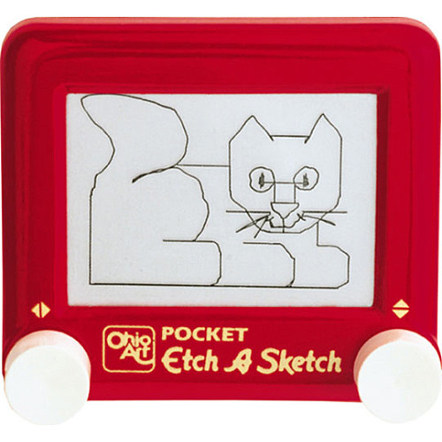

Figure : The exact pocket Etch-A-Sketch to be used during competition.

## **Playing Cards**

[TBD] The playing cards will be updated with an appropriate picture once there is a specific set listed in the competition rules.

## **Scotch Blue Painter’s Tape**

The Scotch Blue Painter’s Tape as show in **Fig 10** is the exact painter’s tape that will be used to designate the line the system must follow.

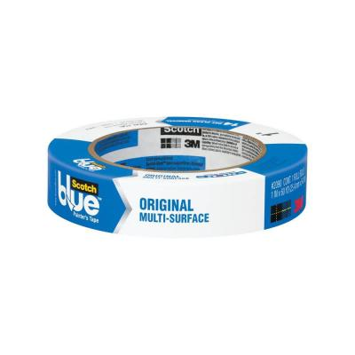

Figure : The exact painter’s tape to be used on the course.

# **References**

[1] IEEE Nova Southeastern University. (2014, September 7). IEEE SoutheastCon 2015 Student Program - Hardware Competition. Retrieved September 7, 2014, from IEEE SoutheastCon 2015: http://www.ewh.ieee.org/reg/3/southeastcon2015/StudentProgram.html

[2] Rembold, U., & Fatikow, S. (1997). Autonomous Microbots. Journal of Intelligent and Robotic Systems, 19(4), 1.

[3] SoutheastCon. (n.d.). Retrieved September 13, 2014, from http://www.ewh.ieee.org/reg/3/southeastcon/

[4] "IEEE About IEEE." IEEE. N.p., n.d. Web. 12 Sept. 2014, from http://www.ieee.org/about/index.html.